# Removing Applications from IIS-DEV

NOTE: You can only connect to IIS-DEV via remote desktop from within the Polytech Network as the firewall on iis-dev blocks all other IP Addresses.

1. Open Remote Desktop Connection
   1. Enter the address iis-dev.op-bit.nz

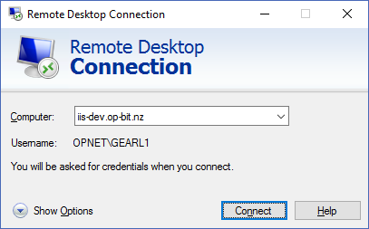

* 1. Click Connect
  2. Enter your Password and click Ok (Should the Username displayed not match your username select more choices, Use a different account)

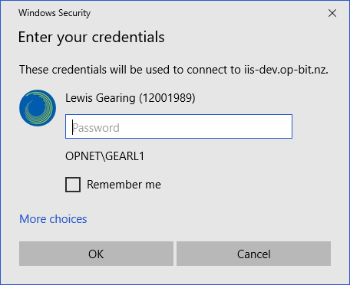

* 1. On the prompt that the remote computer cannot be verified, check the computer name matches the one in the screenshot below then click yes (if it does)

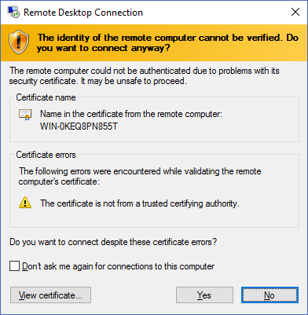

1. Once Logged into the server
   1. Open Server Manager (Should it not already be open)

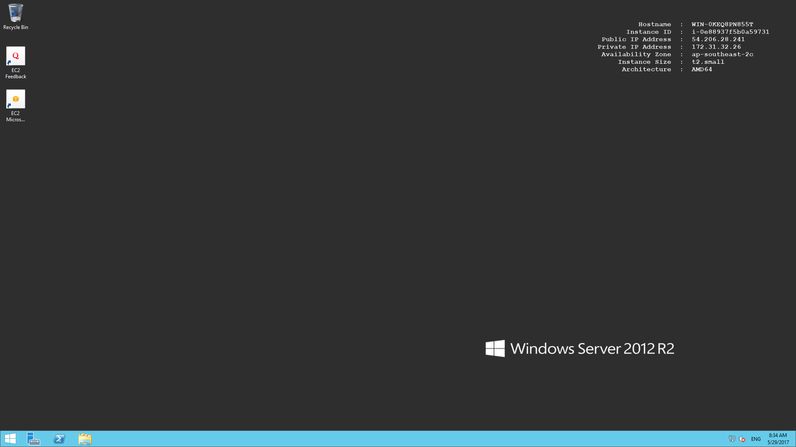

* 1. Once the Server Manager is open, select Tools, Then Internet Information Services (IIS) Manager

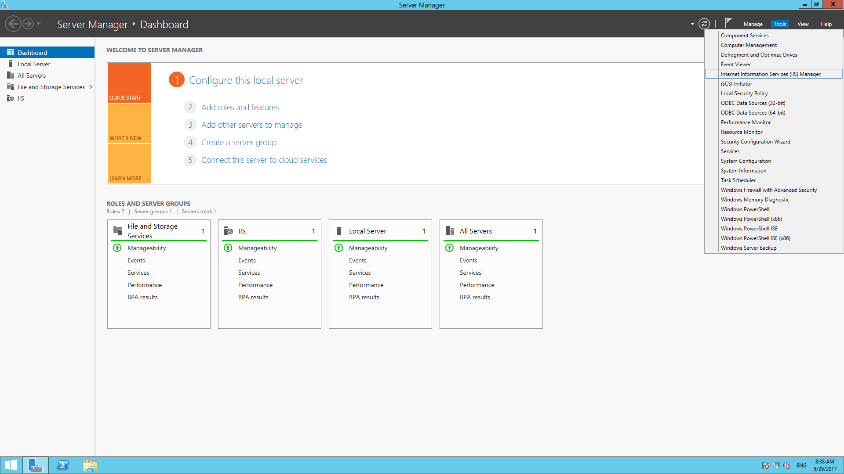

* 1. Once IIS Manager is open, in the Connections Tree on the left, Expand the tree until you have opened CommSoft

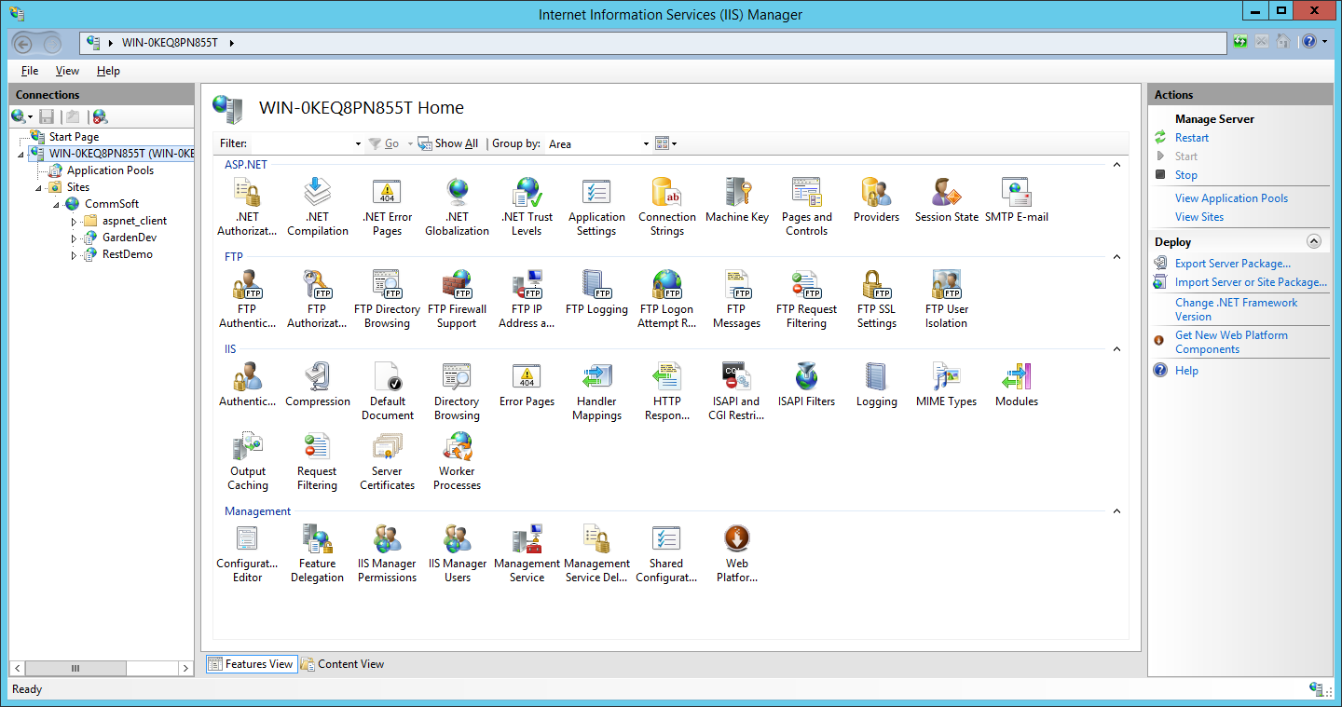

* 1. Right Click on the Application you wish to remove, and click Remove



* 1. The application is now removed
  2. You can now logout of your remote desktop session